# Scenario Overview

This hard drive is based off the recent film “Let’s be Cops” where two friends, Nick and Justin, wear police uniforms to a party, then on their way home are mistaken for real policemen. Instead of explaining they are just in costume they act as if they are real police. Enjoying the experience they continue to pretend they are police and abuse the power.

Nick then proceeds to buy a police car on eBay along with a police radio and starts attempting to solve crimes. They’re then approached by the police, but manage to convince them that they’re real officers. The two of them are put on real cases and quickly get way over their heads.

# Evidence Overview

This hard drive contains evidence of Nick planning to pretend to be a police officer. There is an email explaining how it happened by accident, but it’s something he wants to pursue. There’s also extensive browser search history looking into if it’s illegal. Nick then searches online to purchase a police car and emails Justin saying that he’s hidden a photo of the purchased car using Steganography. Several Steganography tools are installed along with search history on how to steg .bmp files. A further hint in a text file suggests the file name and states that the image is his desktop wallpaper.

Nick has placed this text file in an encrypted zip with the password stored in a password file that he has deleted and is currently being held in the recycle bin. A text file outside the encrypted zip points to which password on the list it uses, but this text file has been bit shifted. He has stated this fact in the file name and in the search history there is evidence of him looking how to do it using the Hex Workshop. Both this file and the zip have also been placed within a secret folder on the desktop with a modified CLSID, so when looking on the desktop you only see a link to my computer. However, there is a hidden .bat file on the desktop that when run returns the CLSID to its normal state, allowing you to view the contents.

The deleted password file mentioned earlier contains the encoded passwords which must be decoded using the method that prefixes each one. There are several fake passwords to try and throw people off, but the real passwords for the stegged image are easily identified as ‘steg1’ & ‘steg2’.

Another email mentions surveillance photos they have been taken using stolen police equipment have been hidden in an encrypted drive. There is evidence that Truecrypt has been installed on the computer, but with it no longer being secure, internet history shows that Nick decided to use BitLocker instead. An email states that he has hidden the password to this encrypted area in a filename or photo. There is an image where the filename contains ‘Pa55wd’, with the password followed after it.

In Nick’s pictures there is a zip which is actually an image with the file extension changed and the header changed from JFIF to ZIP. When reverted back it clearly shows both suspects, Nick and Justin, along with the police car purchased.

Another email from Justin mentions to make a list of police gear they have and that he should split it up. GSplit has been installed and a file can be found in a bad sector on an otherwise empty drive. This suggests the file has been split up and the text file gives the locations of the 6 parts that have been scattered across the hard drive. Each file contains the word ‘GSplit’ so can also be easily found via a word search. Once all the files have been collected into the same directory and given the correct file extensions there restorer exe can be executed to restore the file. It initially appears to just be the explorer.exe file, but opening it in notepad and scrolling down reveals the hidden list.

# Summary of Evidence Items

There are 12 evidence Items as follows:

1. [Type 01] – (Email) – A series of emails between Nick and Justin:
   1. Nick explains how he and Justin are pretending to be police officers and hiding files in a protected drive.
   2. Nick tells Justin that he bought a police car on eBay and used Steganography to hide an image of it.
   3. Nick states that illegal photos have been hidden on a secret drive.
   4. Justin tells Nick to split up a list of stolen police gear.
2. [Type 01] – (Internet History) – A list of searched terms in Firefox:
   1. Is it illegal to impersonate a police officer
   2. Trying to purchase a police car
   3. How to split up a file
   4. Whether to use Truecrypt or Bit Locker
   5. Best ways to hide passwords
   6. How to use Steganography on .bmp files.
3. [Type 02] – (Text File) - Password file with prefixed encoded method and related file found in recycle bin.
4. [Type 05] – (Steganography) - Stegged image of purchased cop car.
5. [Type 01] – (GIF) – Password for Bitlocker hidden in file name (contains the string Pa55wd).
6. [Type 04] – (Bitlocker) – Password protected drive containing images of suspects they’ve been tracking.
7. [Type 02] – (Zip) - Photo of suspects with file extension and file header changed.
8. [Type 03] – (Bad Cluster) Text file that lists the locations of the GSplit files hidden in a bad cluster.
9. [Type 04] – (GSplit) A list of SWAT items taken from police, hidden in a .exe and split into multiple files scattered across the hard drive.
10. [Type 02] – (Secret Folder) – Secret folder that uses a hidden bat script to change its CLSID so it looks and acts as My Computer.
11. [Type 02] – (Text File) – States the password to item 12 is the 10th password listed in item 3. The file has been bit shifted right.
12. [Type 04] – (Encrypted Zip) – Contents explain the stegged file is his wallpaper and the file name ends in a 7.

# Passwords

## Microsoft

**Username:** [nick._.miller@outlook.com](mailto:nick._.miller@outlook.com)

**Password:** !QAZ1qaz==

## Encrypted Zip

**File:** C:\Users\Nick\Desktop\MyComputer\nothing here.zip

**Password:** rush2112

## Bitlocker

**Password:** m6kxxbd_6y1

## Steganography

**File:** C:\Users\Nick\Pictures\Windows 10 Desktop\Windows 10.bmp

**Password 1:** letsbecops

**Password 2:** wearecops

# Case in FTK Demo

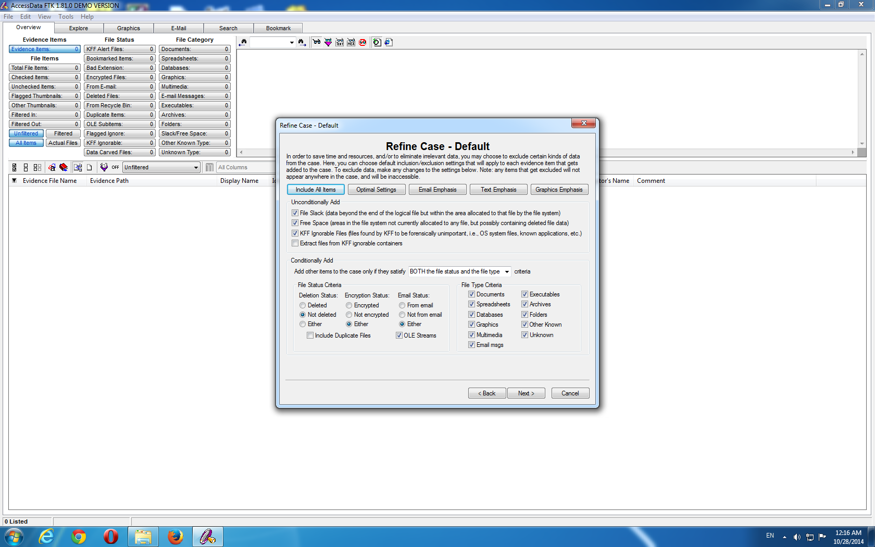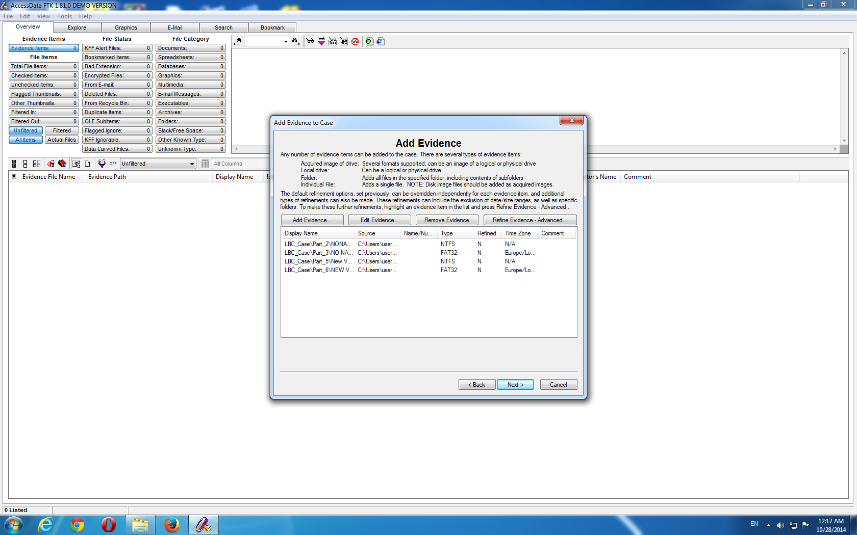 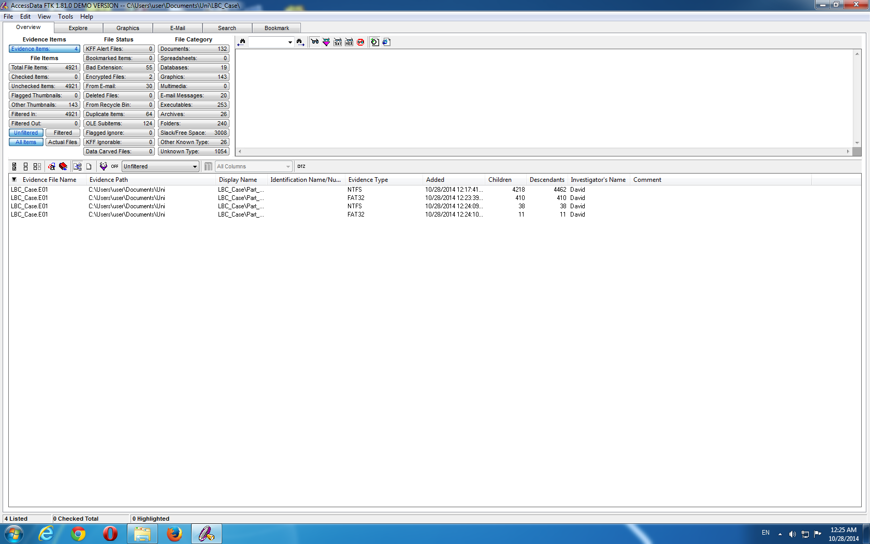

To fit the evidence file into FTK 1.81.0 DEMO VERSION follow these steps:

* Under ‘Refine Case’ the ‘Not deleted’ radio button must be selected & the ‘Include Duplicate Files’ must be unticked.
* In the ‘Add Evidence’ section Part 2, 3, 5 & 6 should be selected, the rest can be discarded.

It will then successfully load into FTK with 4921 items.

# Screenshots of Evidence Items

|  |  |
| --- | --- |
| **Item Number** | **Description** |
| 1 | List of sent emails. |
| Location: | C:\Users\Nick\AppData\Roaming\Thunderbird\Profiles\x4vt1wze.default\ImapMail\imap-mail.outlook.com\Sent-1 |

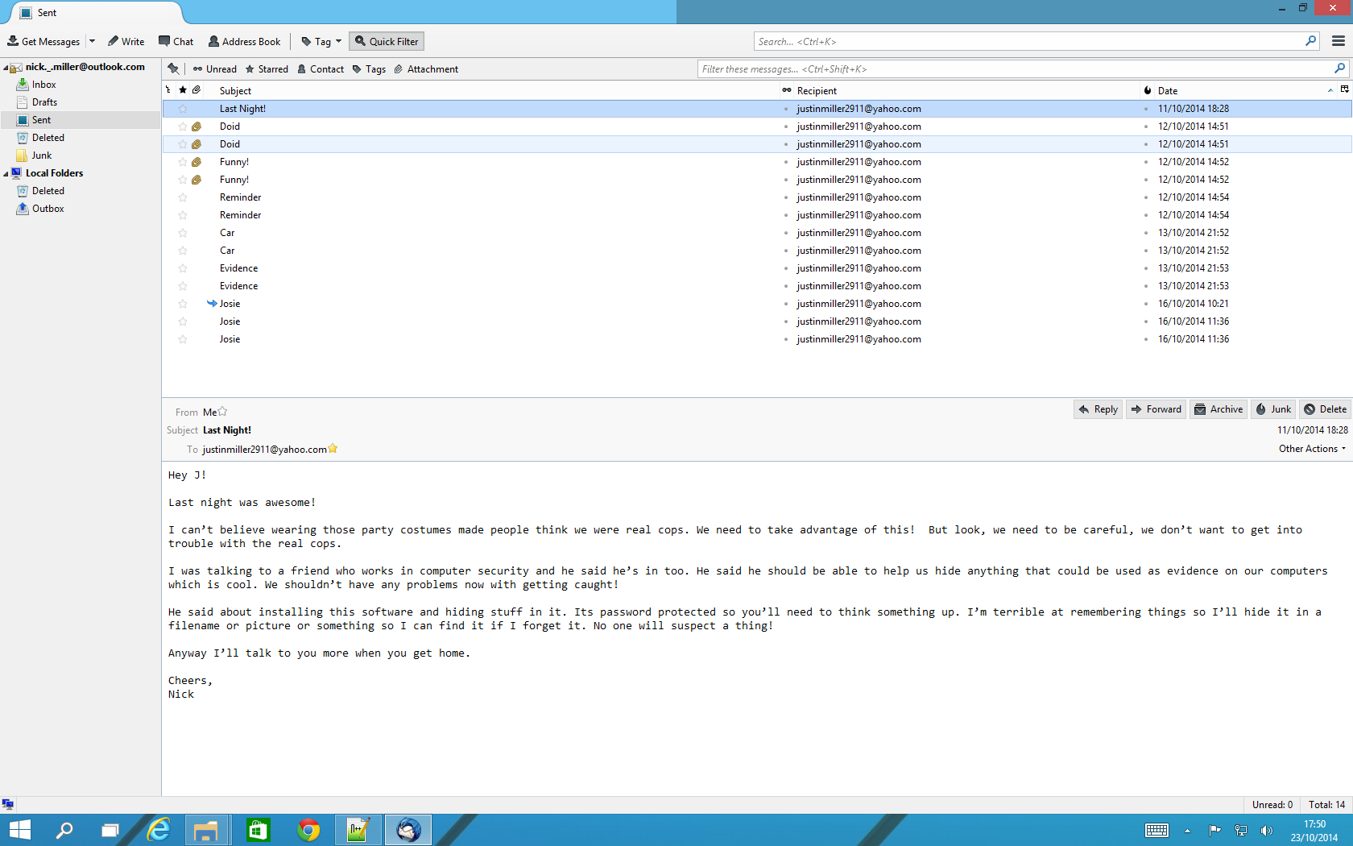 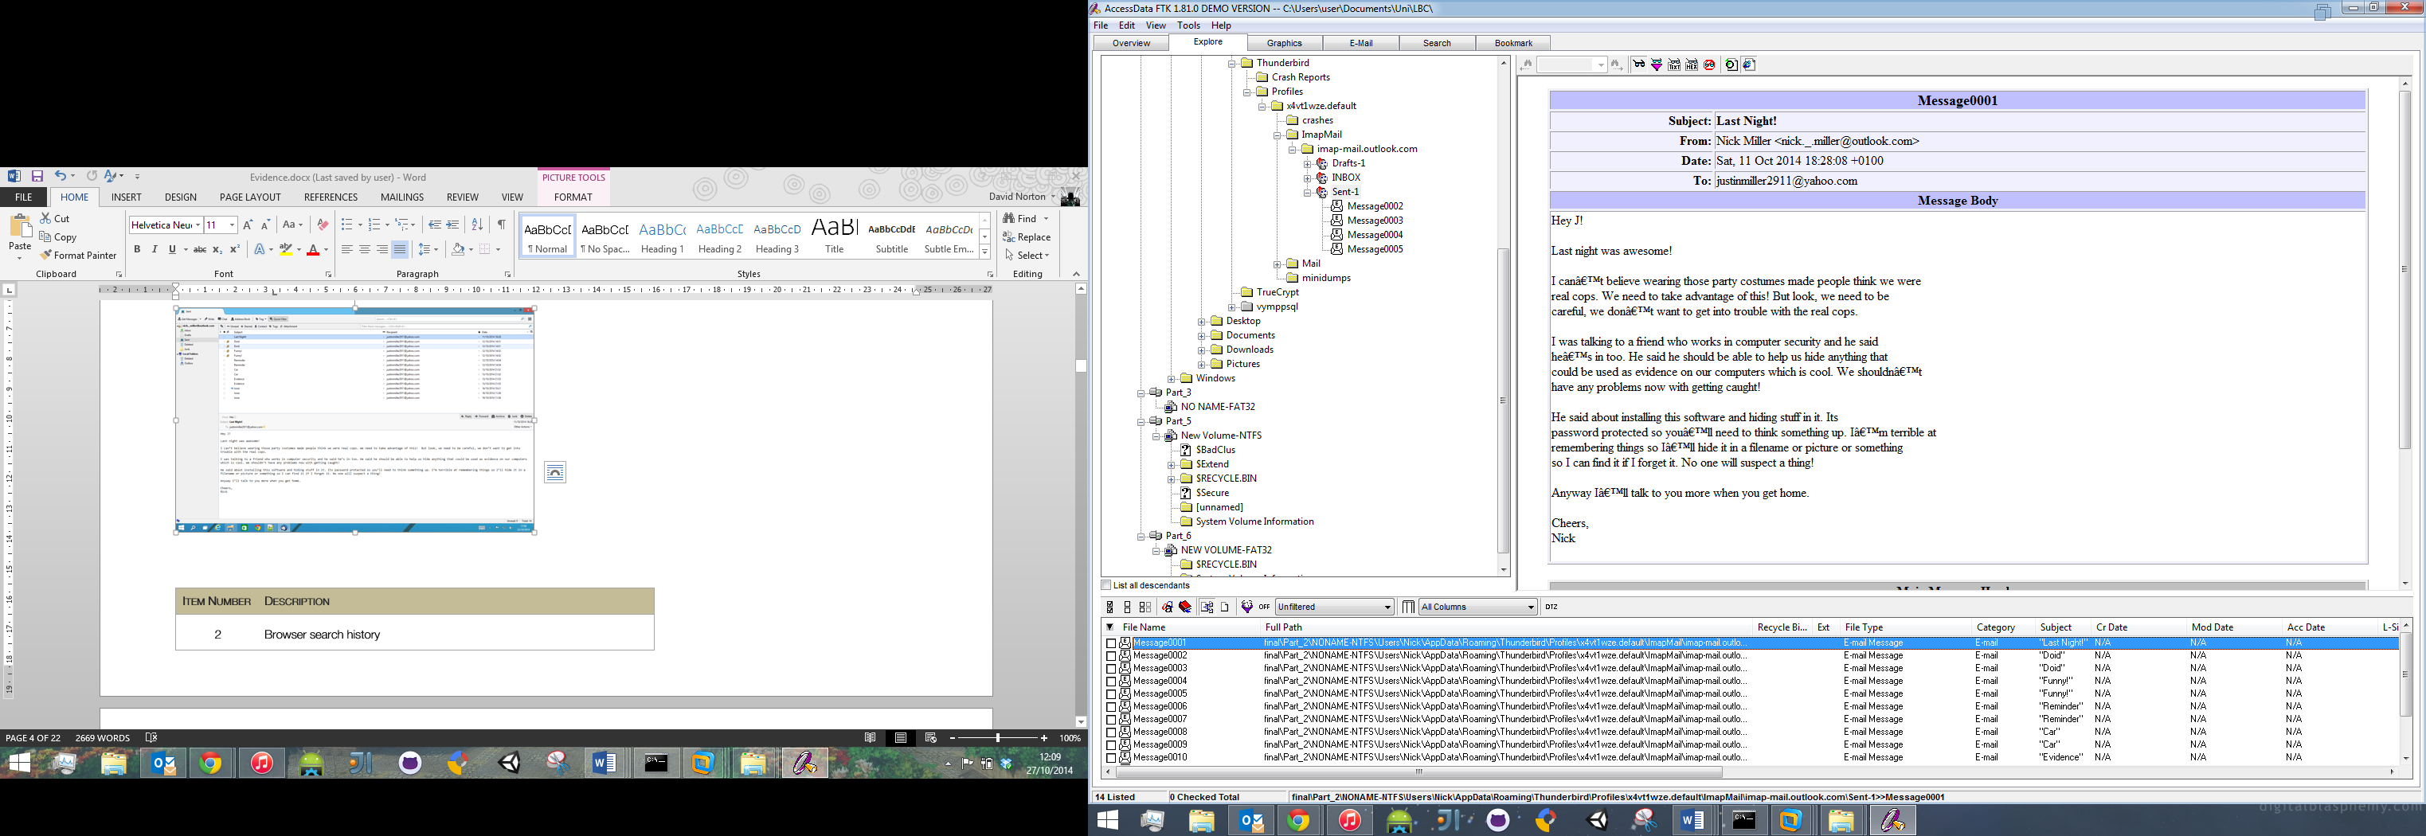

|  |  |
| --- | --- |
| **Item Number** | **Description** |
| 2 | Browser search history |
| Location: | C:\Users\Nick\AppData\Local\Mozilla\Firefox\Profiles\z3gc2lbb.default\places.sqlite |

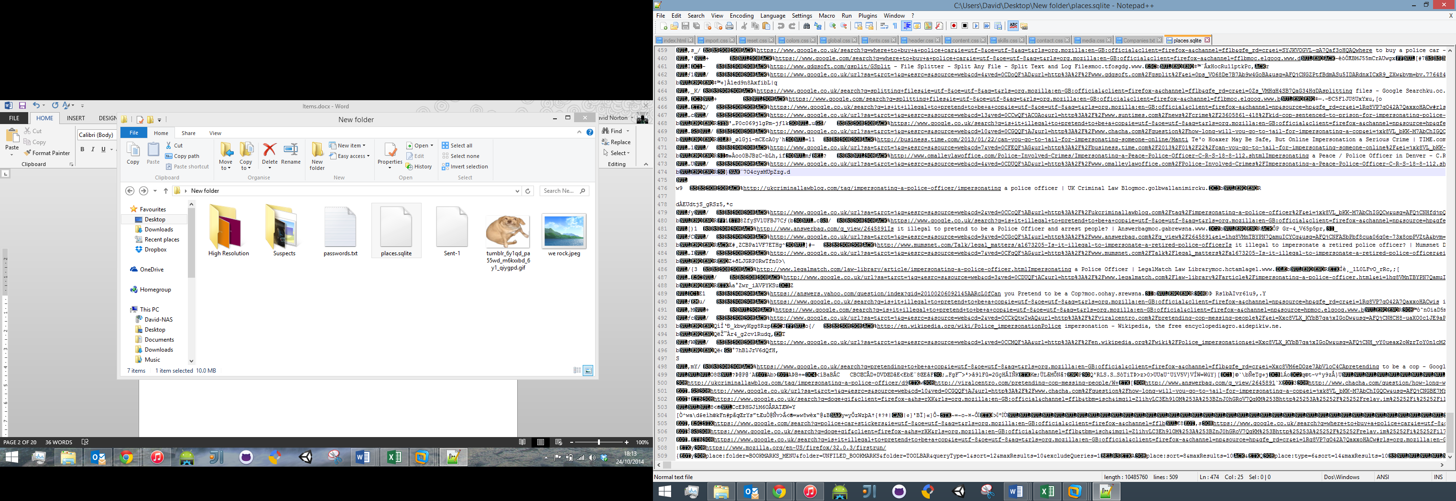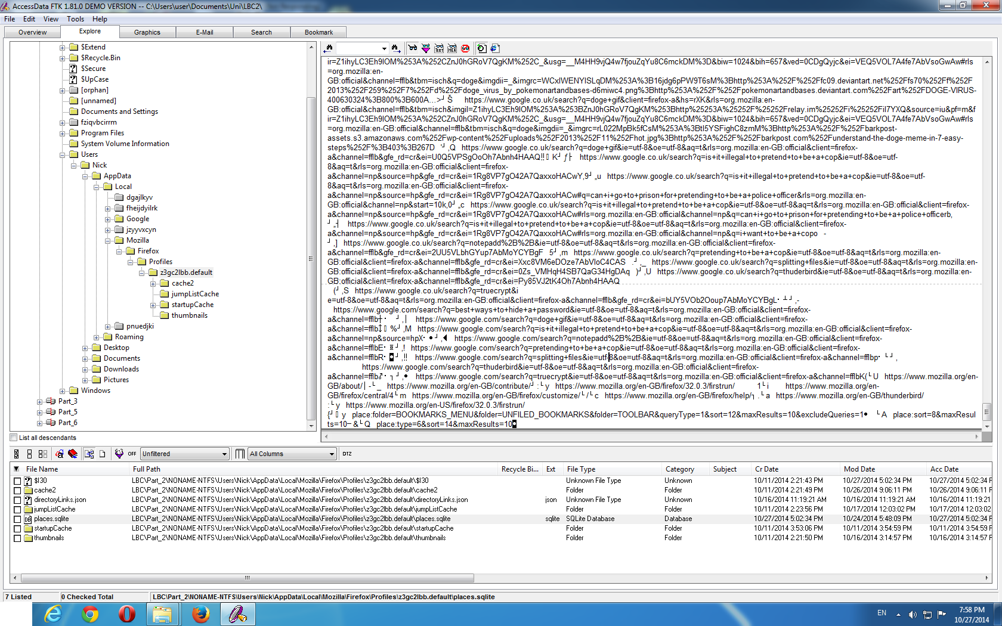

|  |  |
| --- | --- |
| **Item Number** | **Description** |
| 3 | List of encoded passwords. |
| Location: | C:\$Recycle.Bin\S-1-5-21-477737034-4021999012-1167862946-1000\passwords.txt |

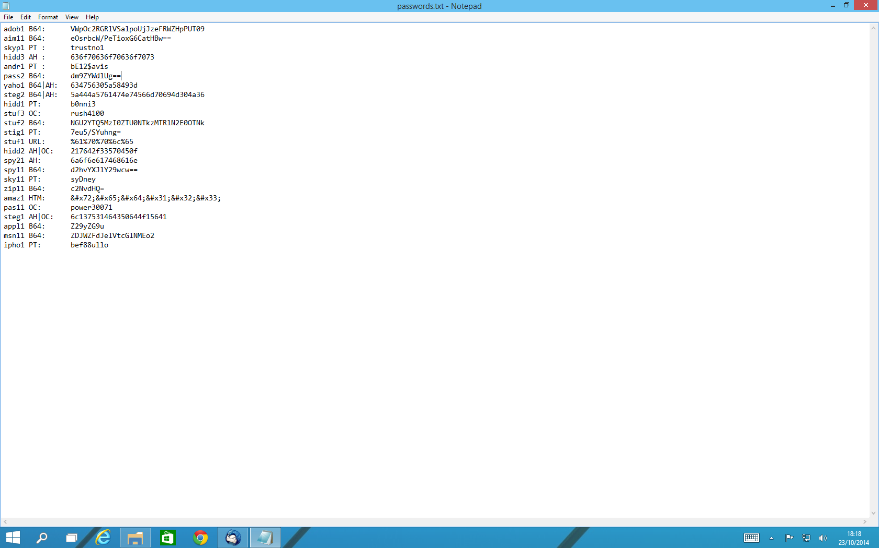Decoded: 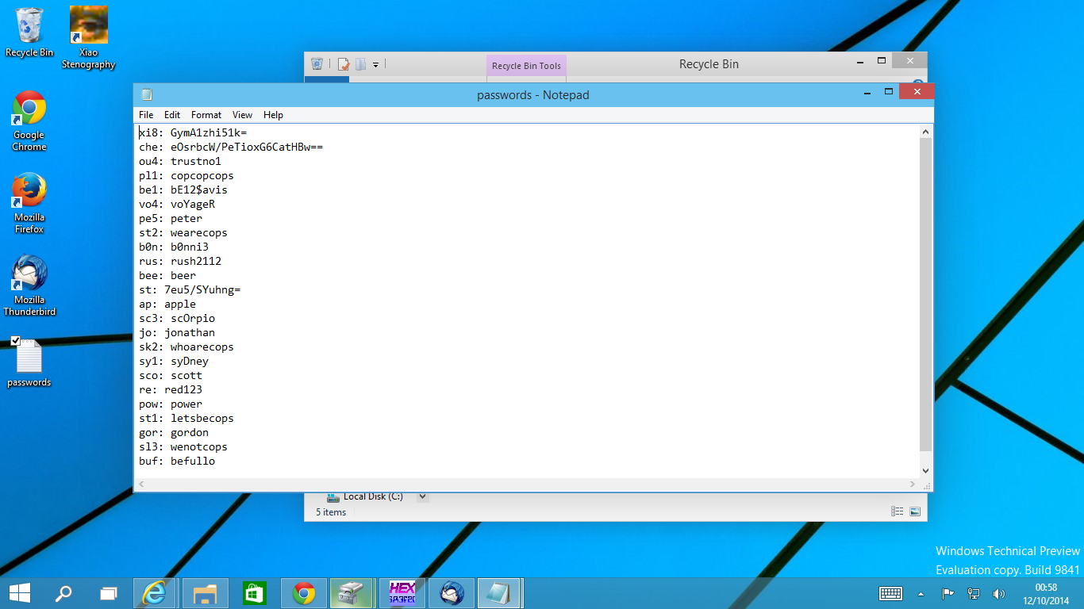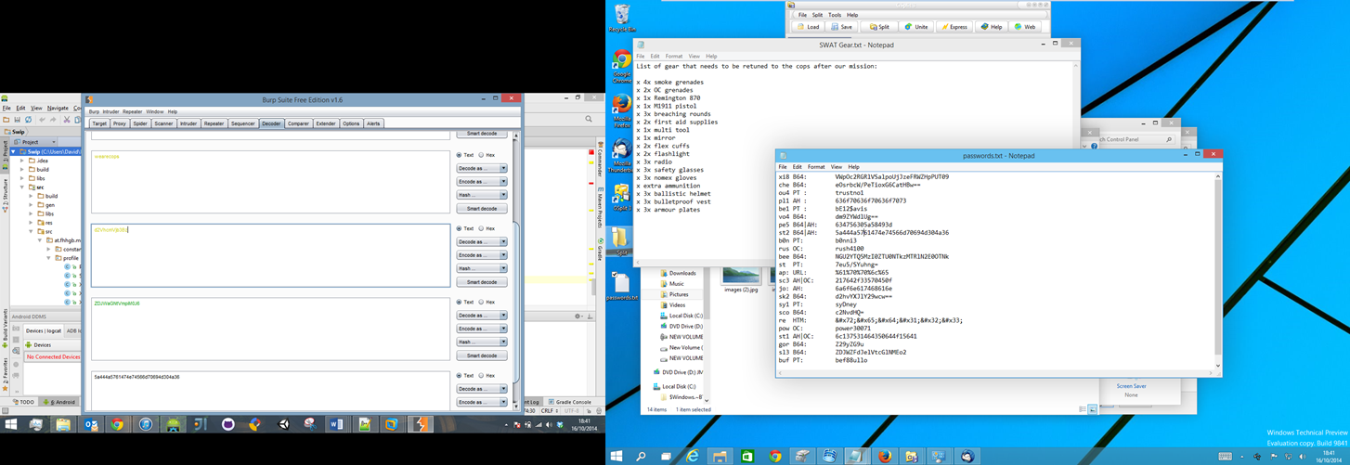

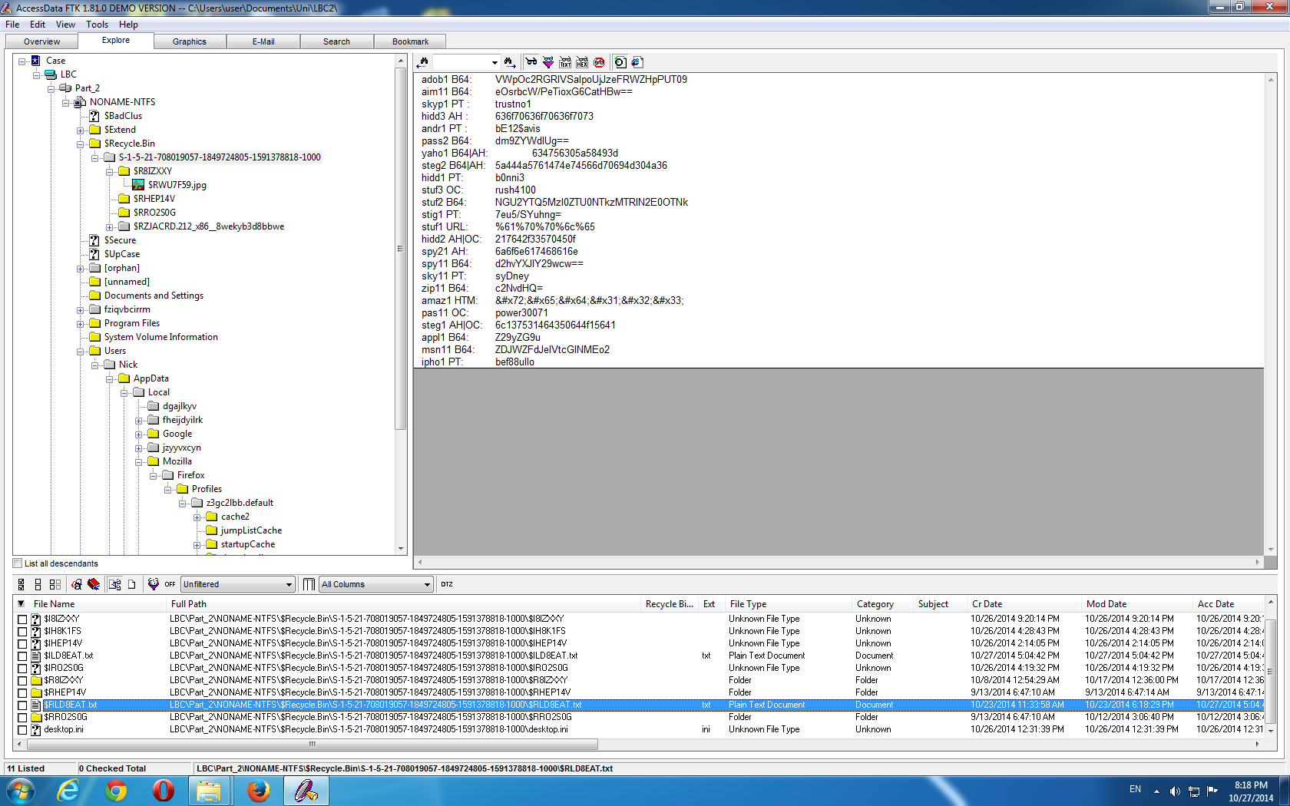

|  |  |
| --- | --- |
| **Item Number** | **Description** |
| 4 | Image hidden in another image using steganography. |
| Location: | C:\Windows\Web\Wallpaper\High Resolution\img17.bmp |

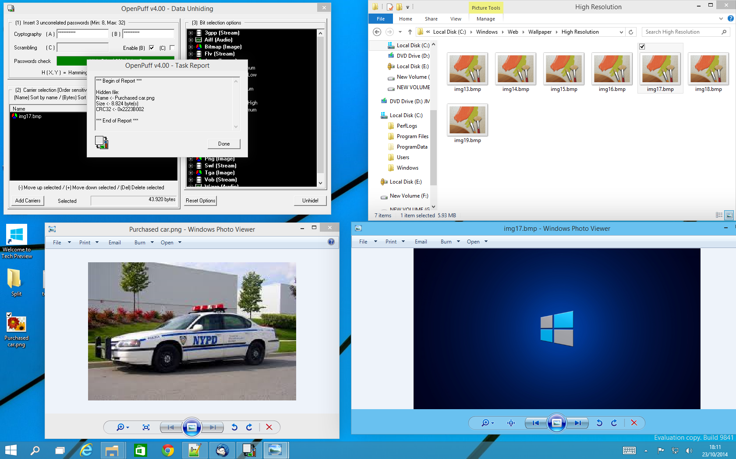 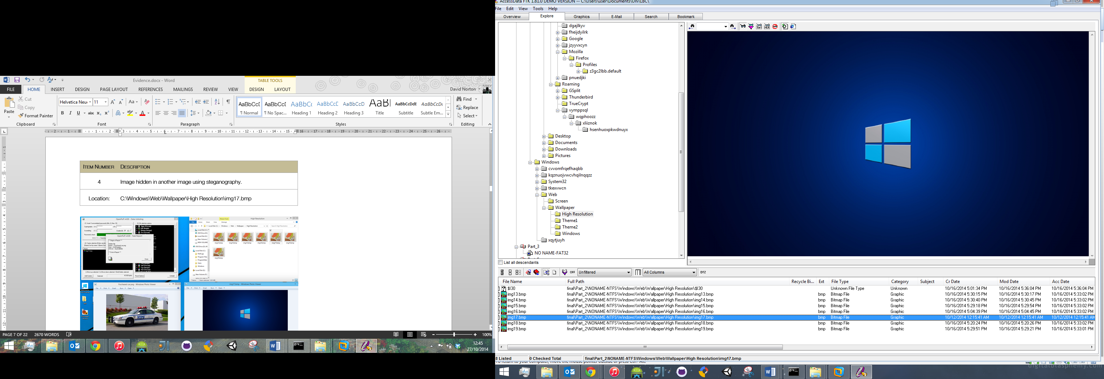

|  |  |
| --- | --- |
| **Item Number** | **Description** |
| 5 | Image containing Bitlocker password in file name. |
| Location: | C:\Users\Nick\Pictures\Funny\tumblr_6y1qd_pa55wd_645920-252879-640728-527032-384032-399773-249854-498135_qiygpd.gif |

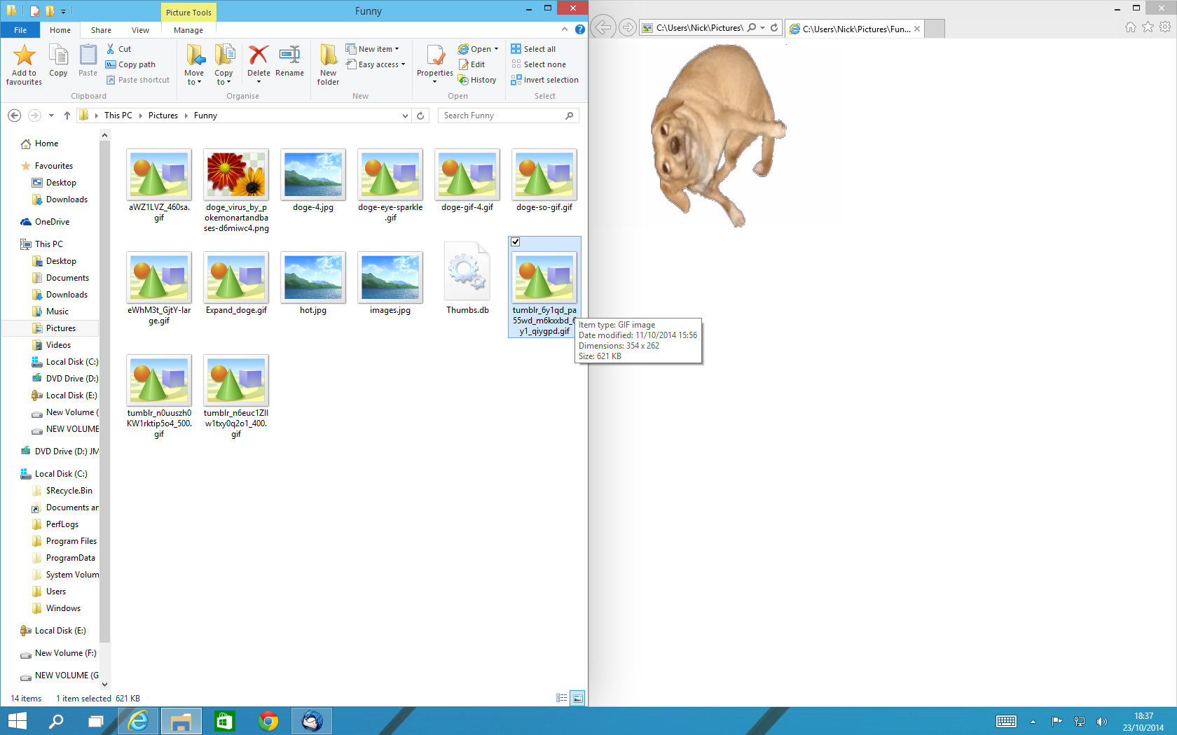 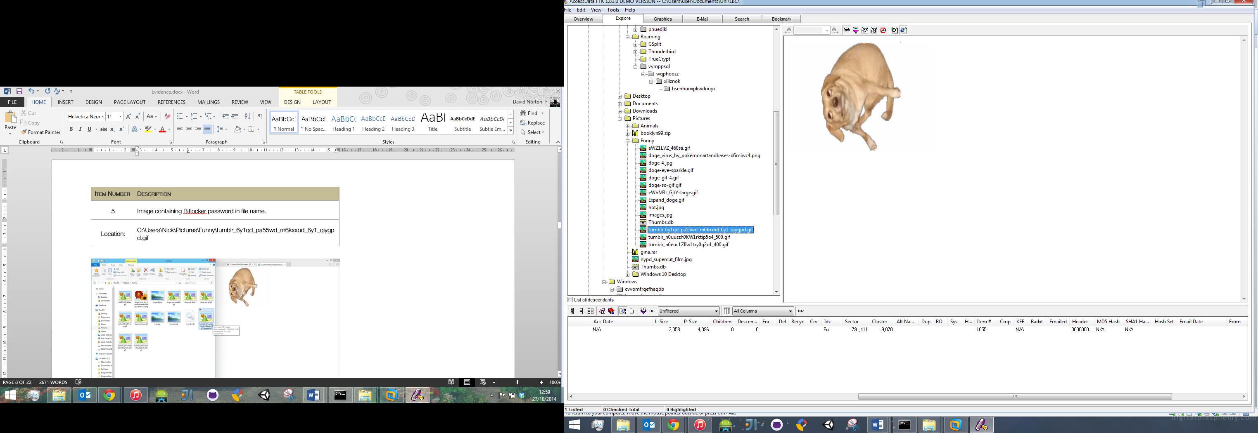

|  |  |
| --- | --- |
| **Item Number** | **Description** |
| 6 | Bit Locker drive containing a folder of photos taken with stolen police equipment. |
| Location: | E:\Suspects |

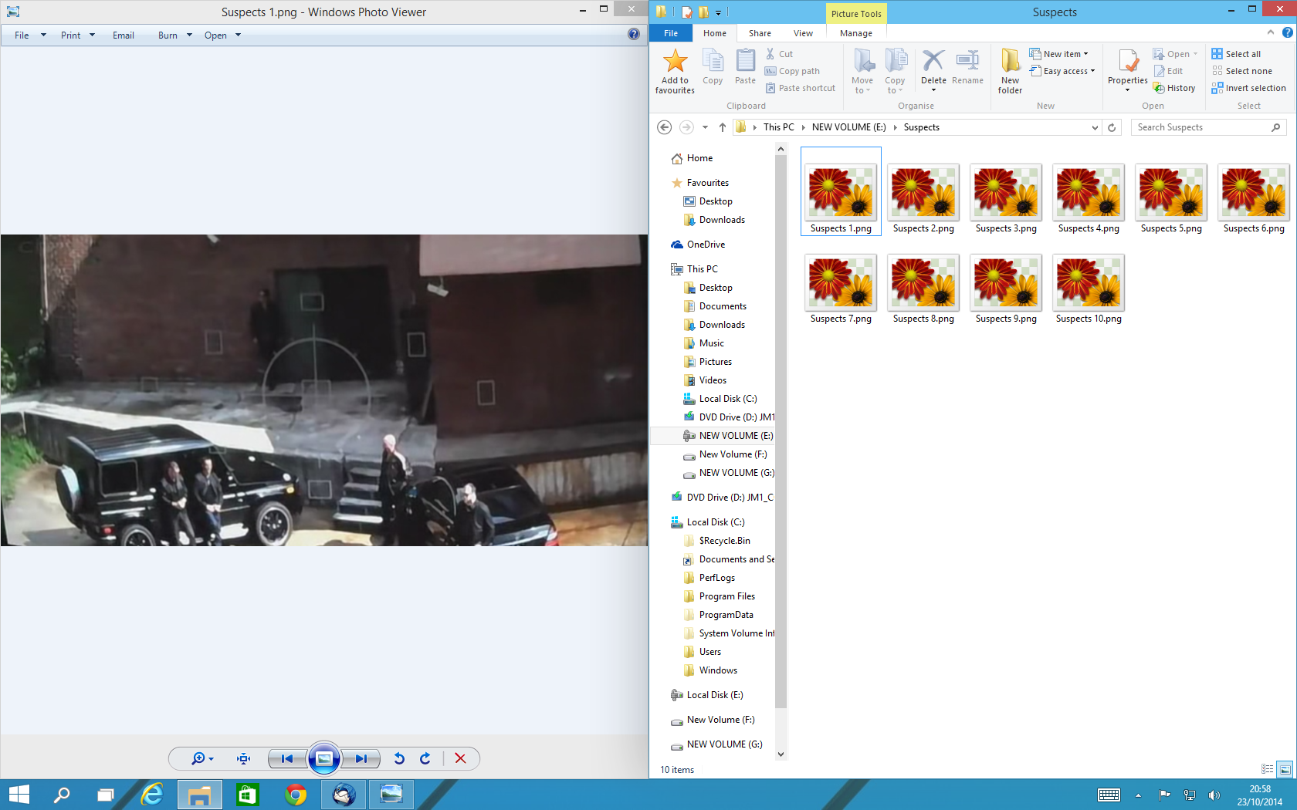 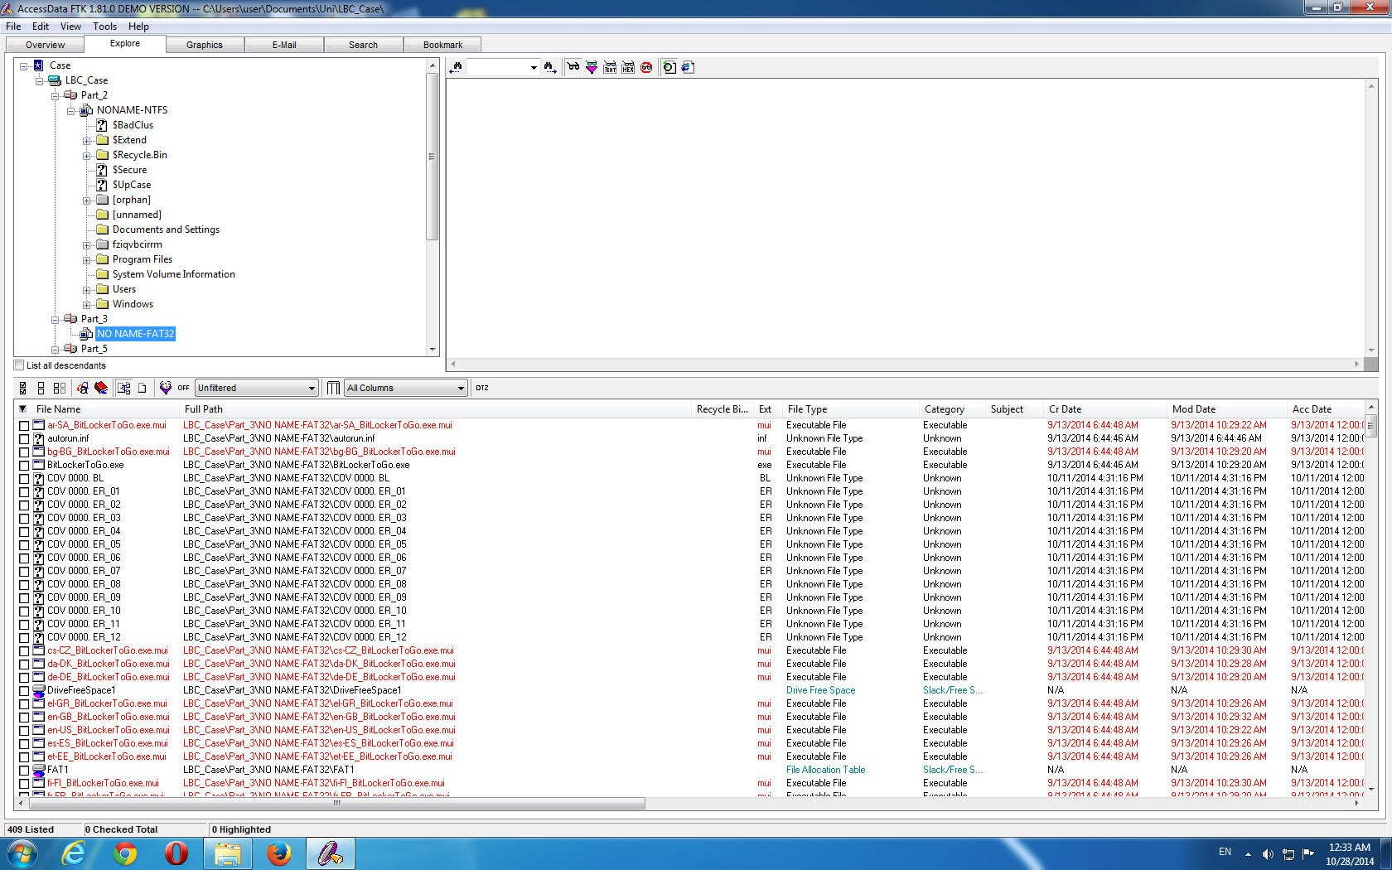

|  |  |
| --- | --- |
| **Item Number** | **Description** |
| 7 | An image of the two suspects and police car hidden as a zip file. |
| Location: | C:\Users\Nick\Pictures\we rock.zip |

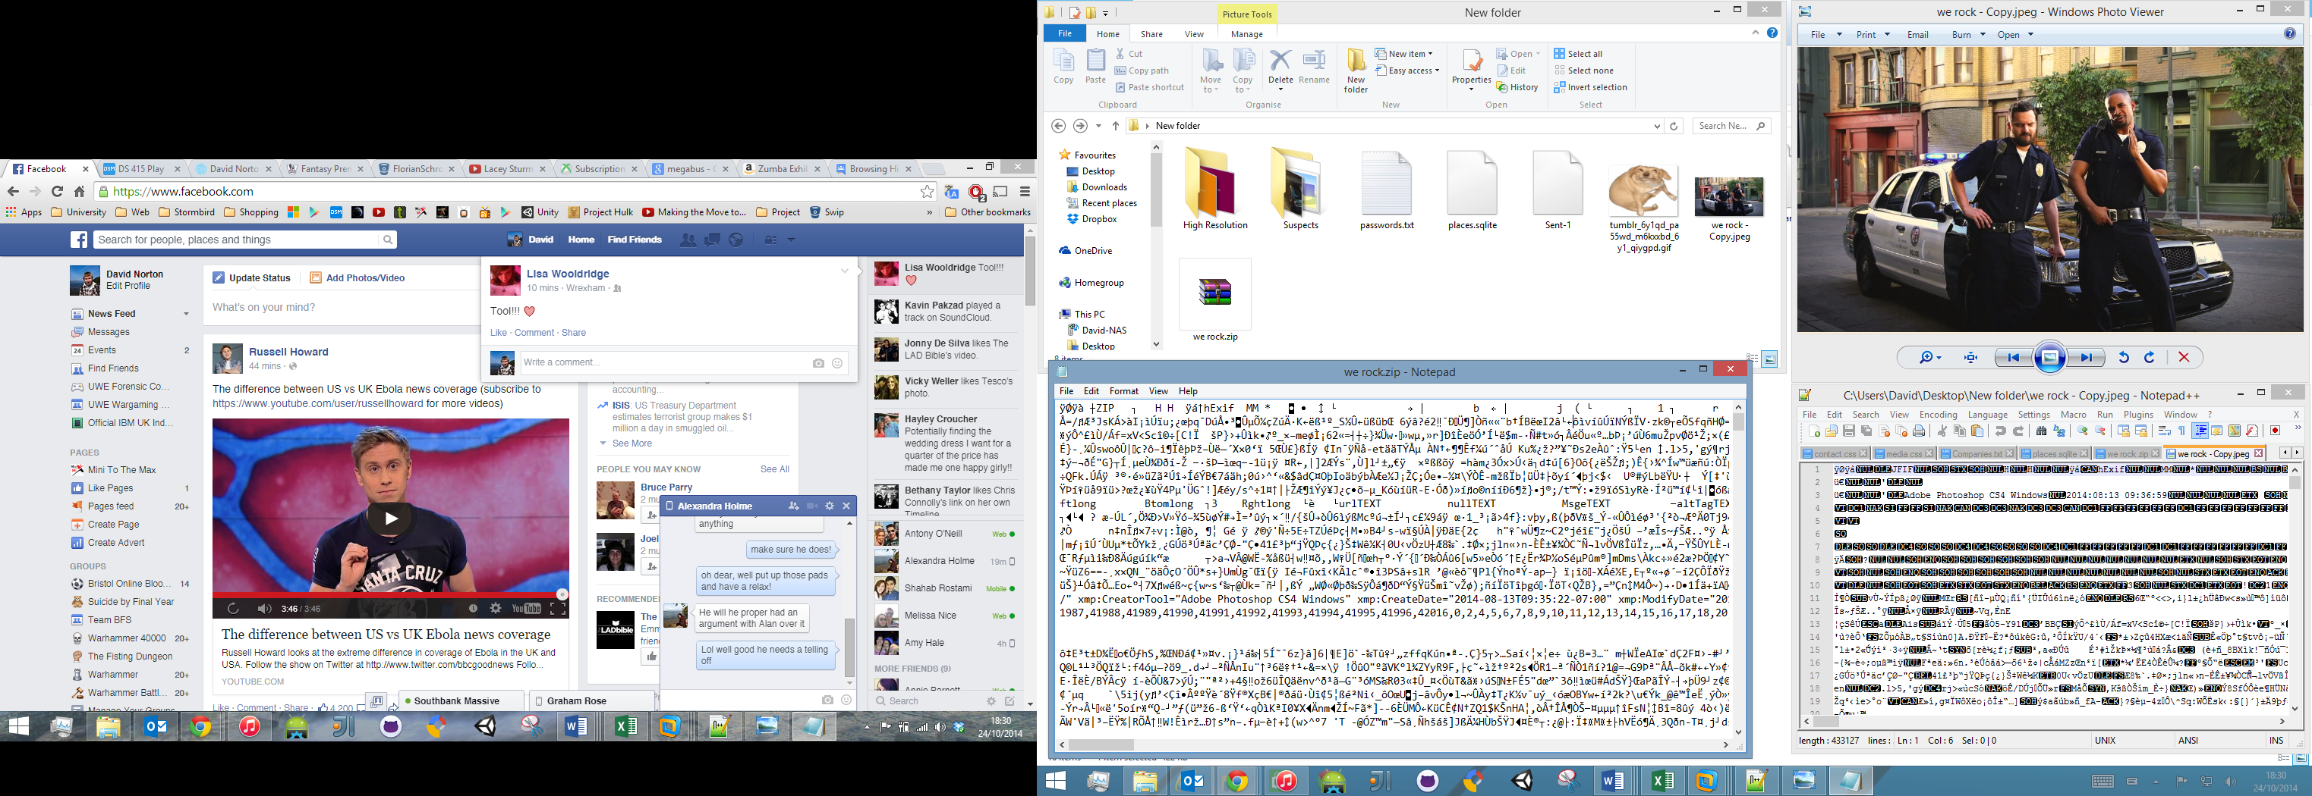 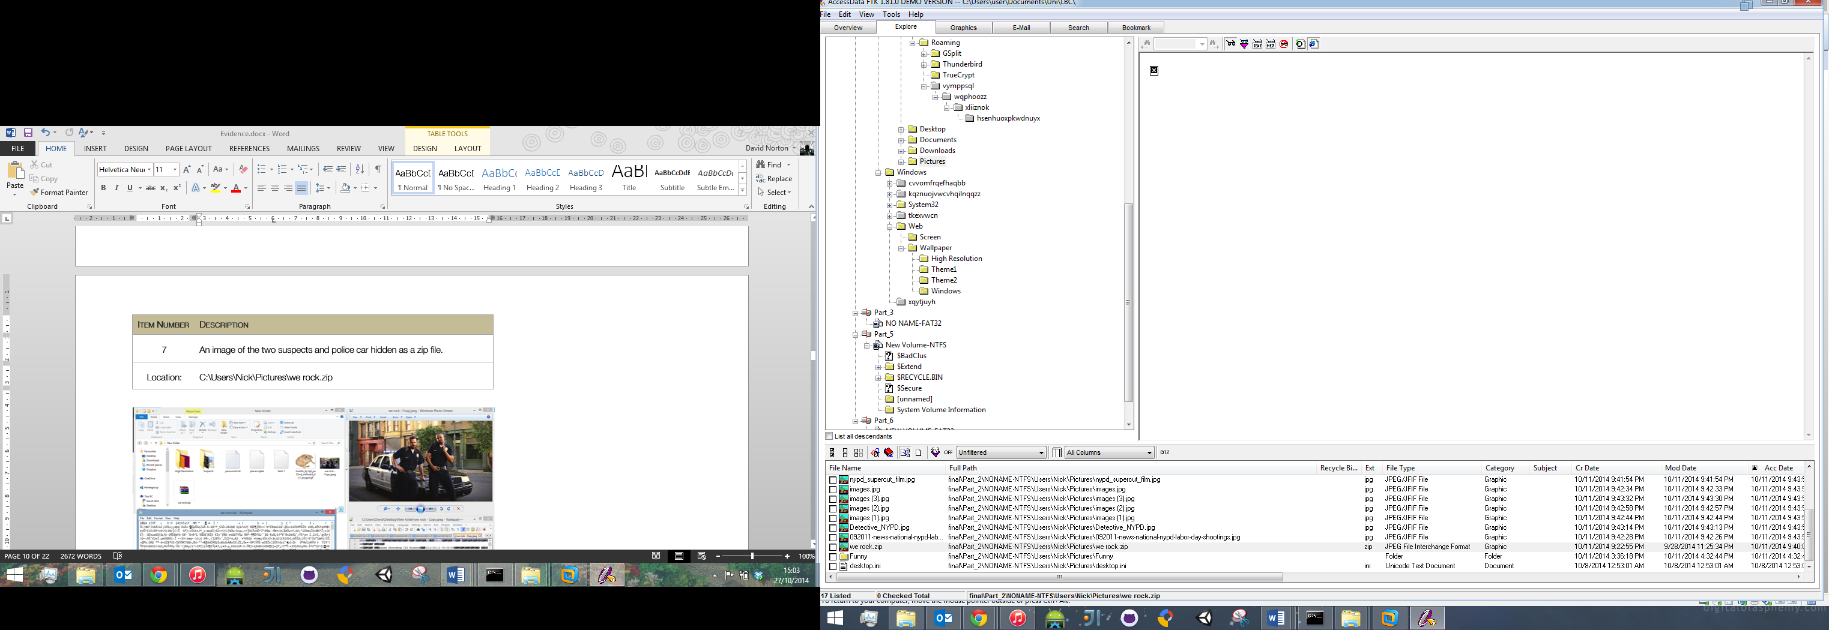

|  |  |
| --- | --- |
| **Item Number** | **Description** |
| 8 | A text file containing the locations of the GSPLIT files hidden in a bad cluster. |
| Location: | G:\NDcyMDZjNmY2M |

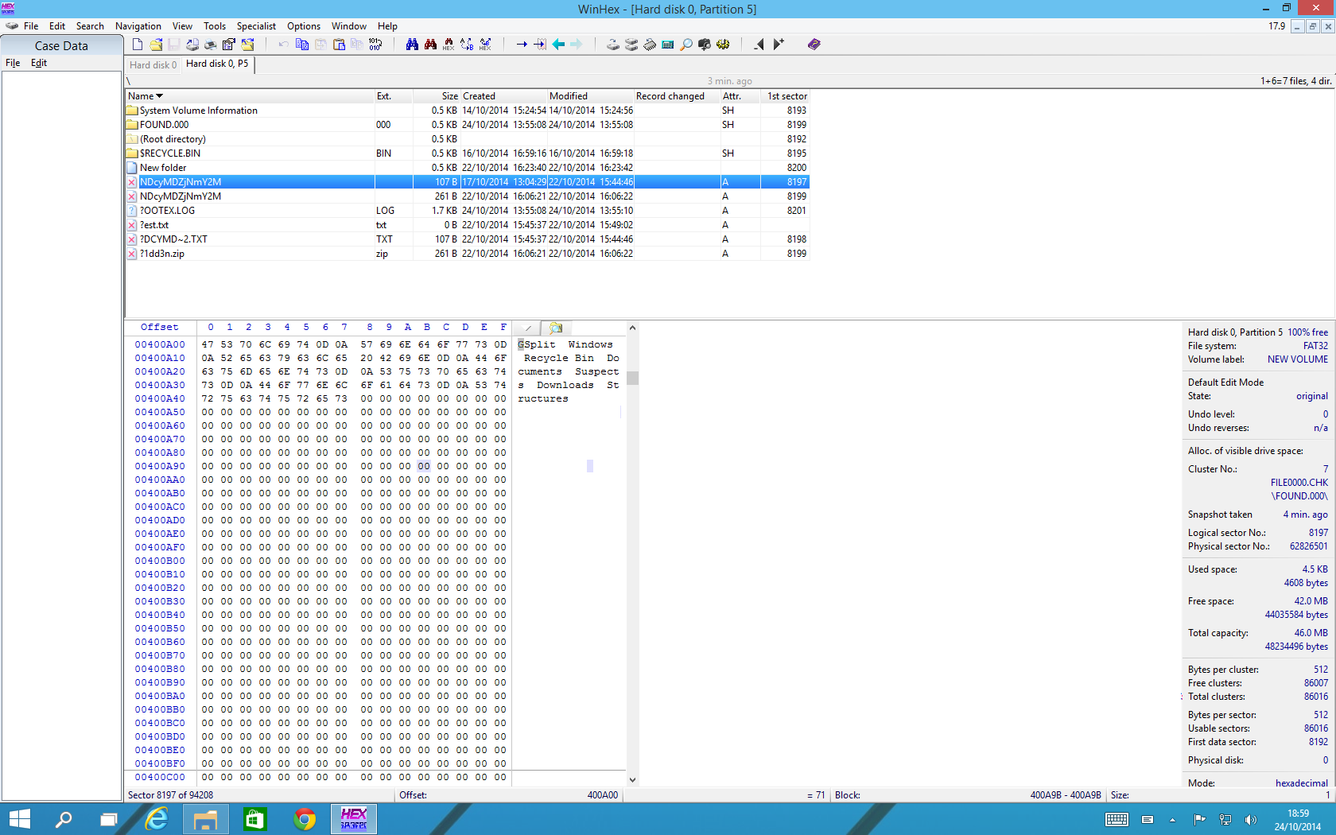 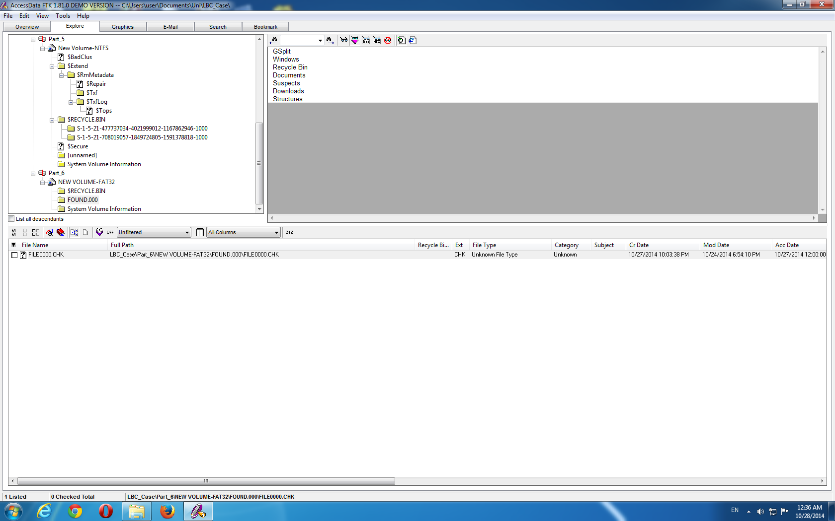

|  |  |
| --- | --- |
| **Item Number** | **Description** |
| 9 | A text file containing a list of stolen police gear that has been split up across the hard drive. |
| Location: | C:\Windows\bfsv.exe  C:\Users\Nick\Desktop\MyComputer\1.exe  C:\Users\Nick\Documents\disk2.gsd  E:\Suspects\Suspects 3.png  C:\Users\Nick\Downloads\testfour.gsd  C:\Program Files\FlexHEX\Structures\5tyle.fsd |

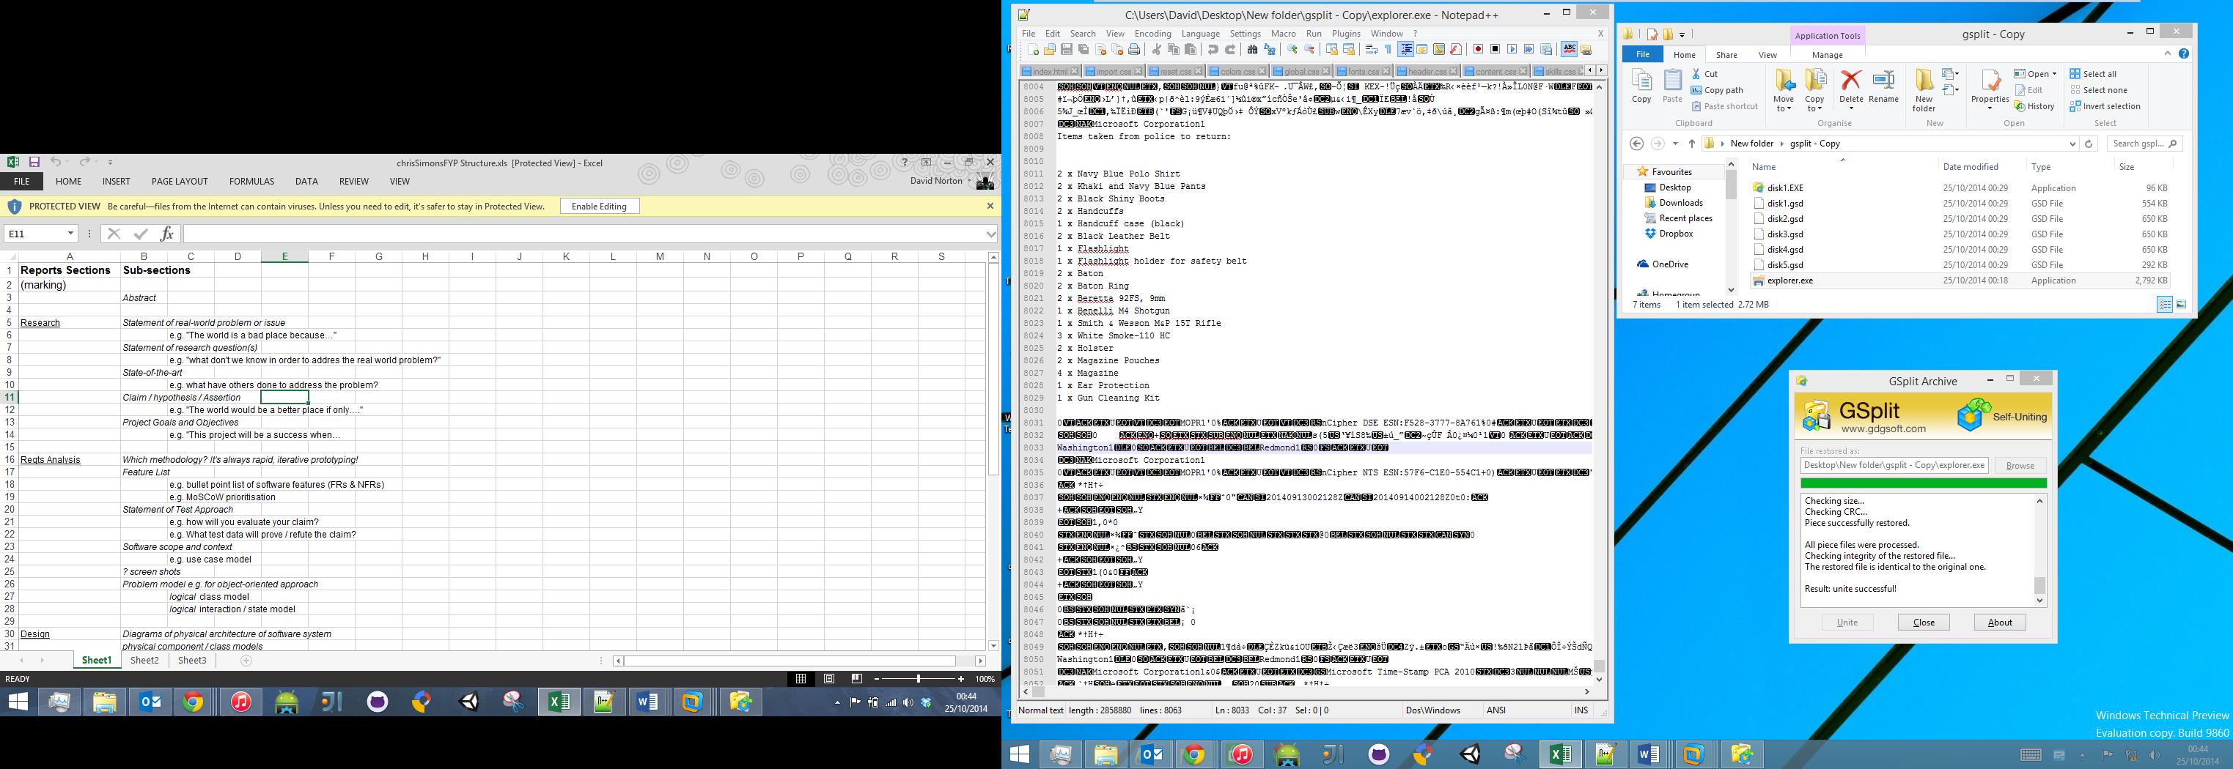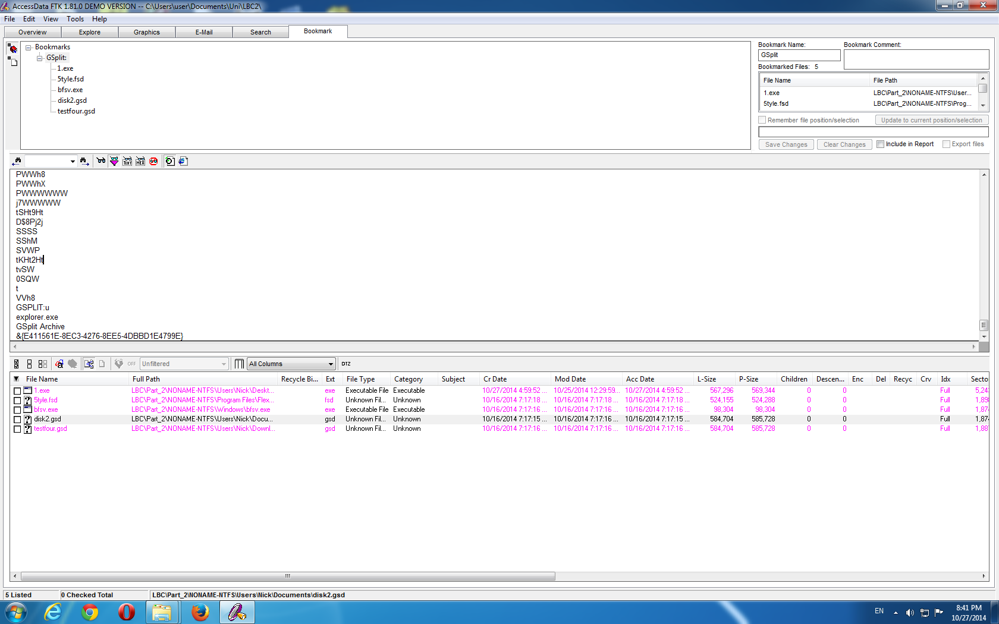

|  |  |
| --- | --- |
| **Item Number** | **Description** |
| 10 | A secret folder that’s hiding other evidence items. A matching .bat file changes the folder’s CLSID so it looks and acts as ‘My Computer’ until run again. |
| Location: | C:\Users\Nick\Desktop\MyComputer  C:\Users\Nick\Desktop\hide.bat |

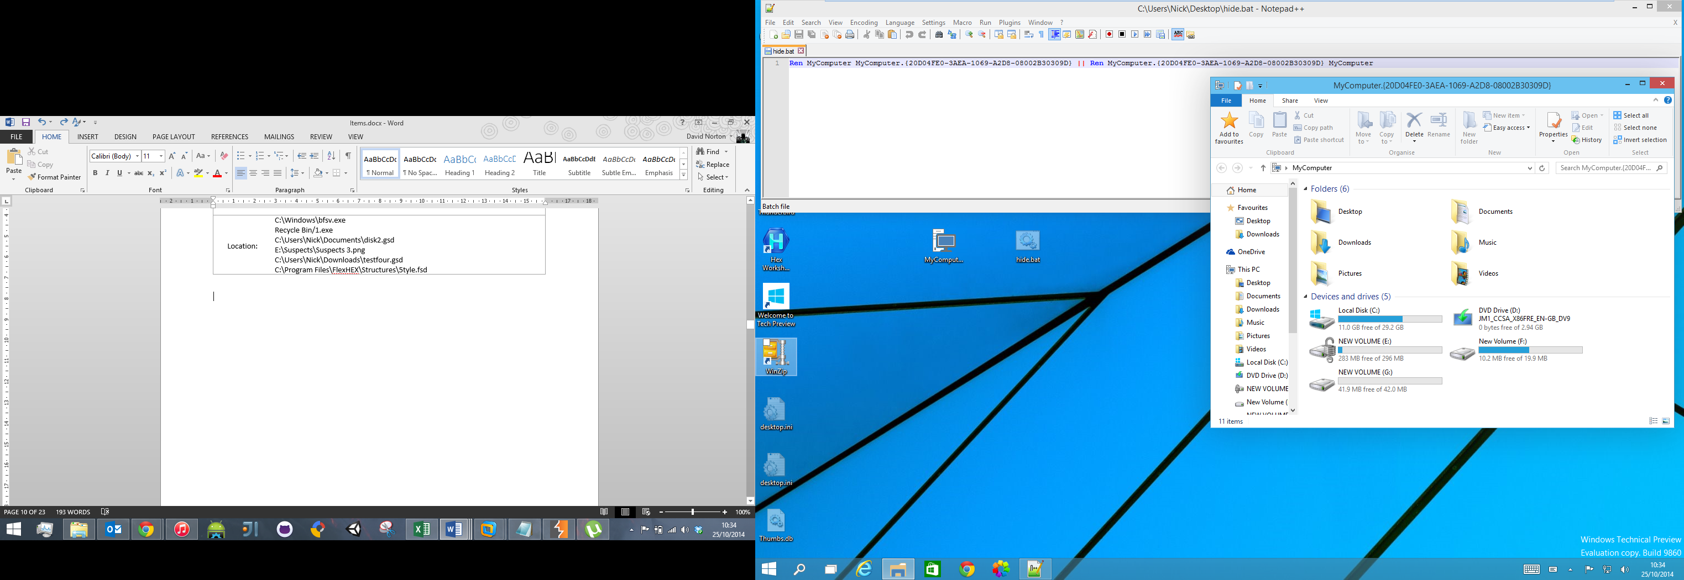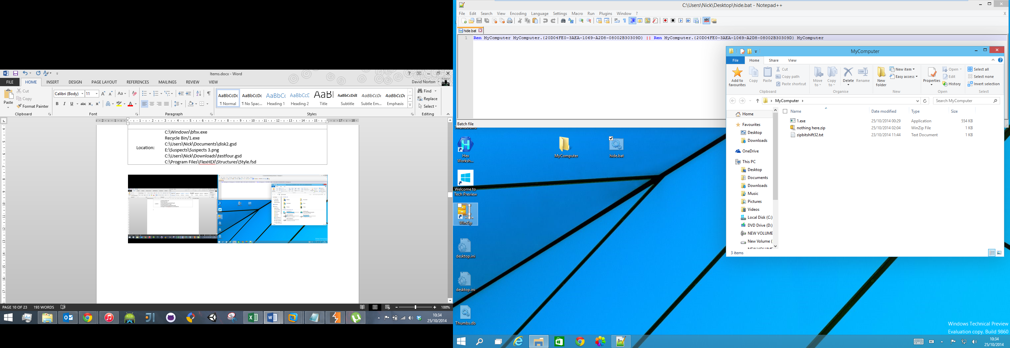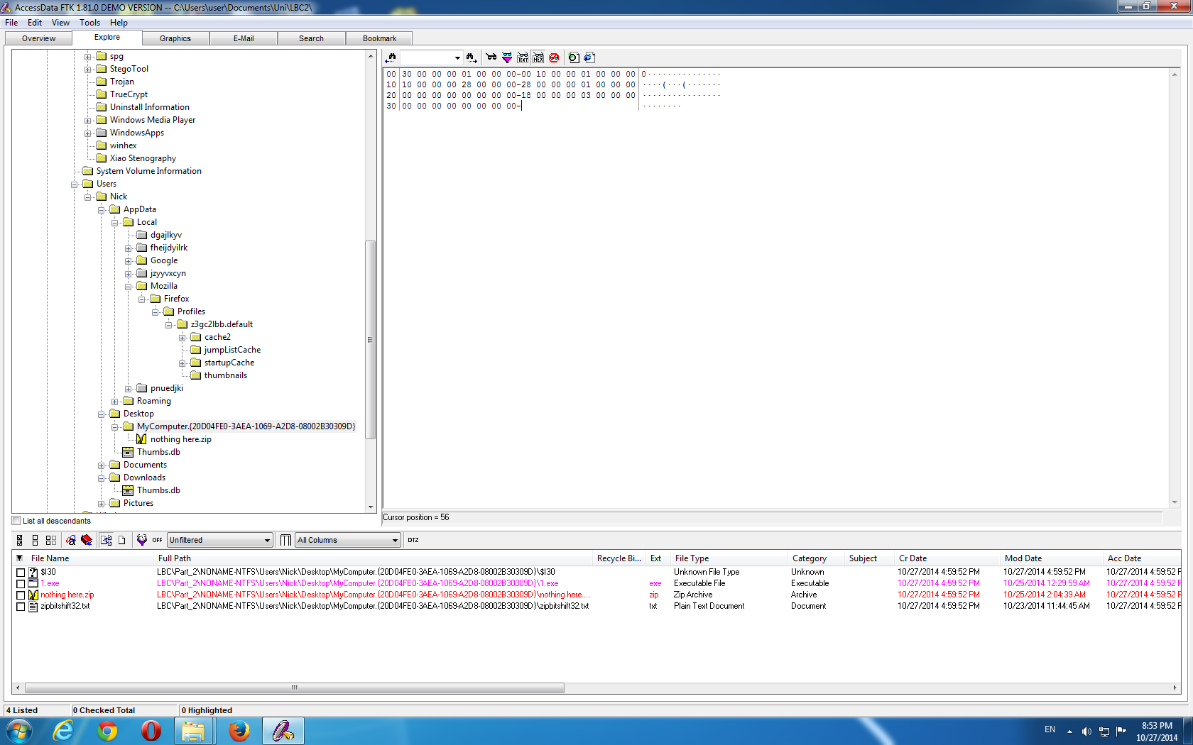

|  |  |
| --- | --- |
| **Item Number** | **Description** |
| 11 | A hint to the password protected zip in the same folder. |
| Location: | C:\Users\Nick\Desktop\MyComputer\zipbitshift32.txt |

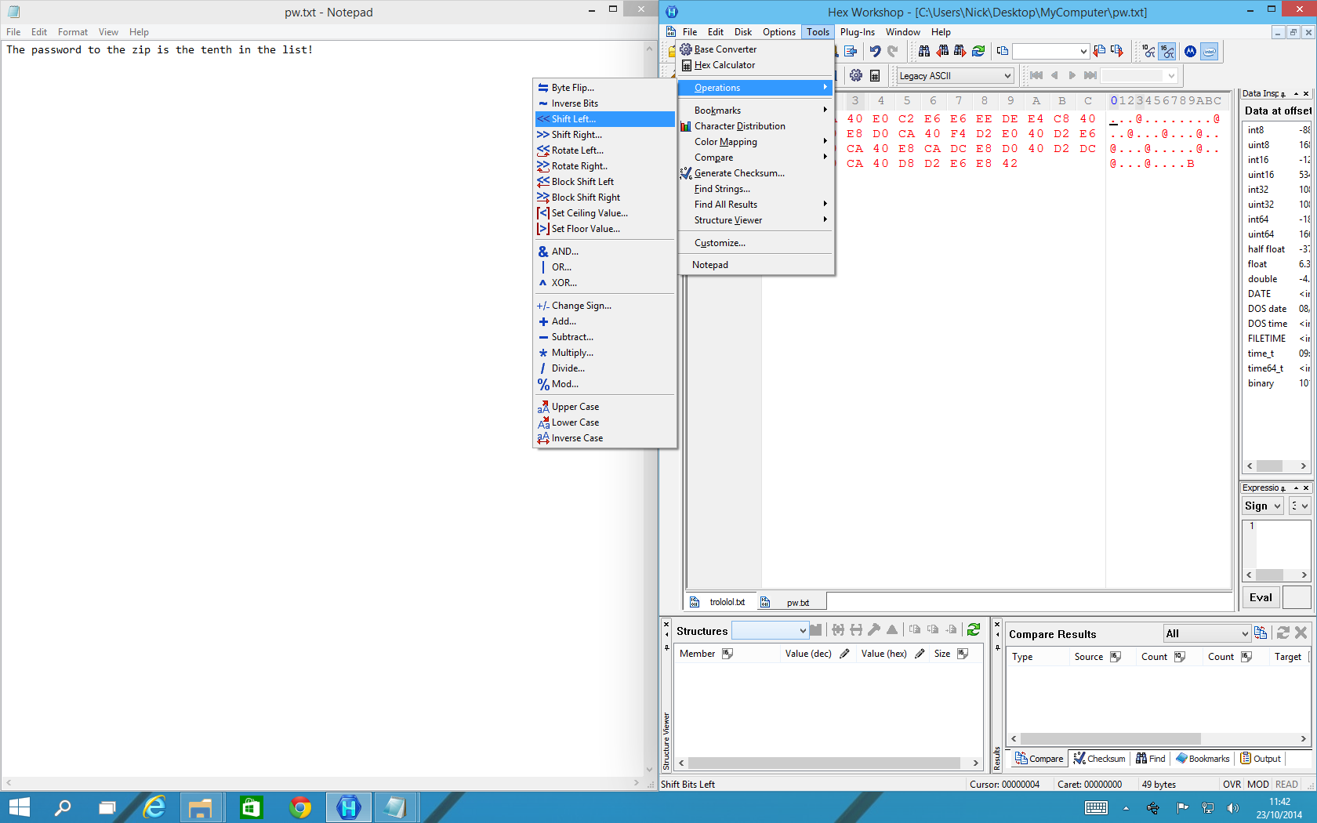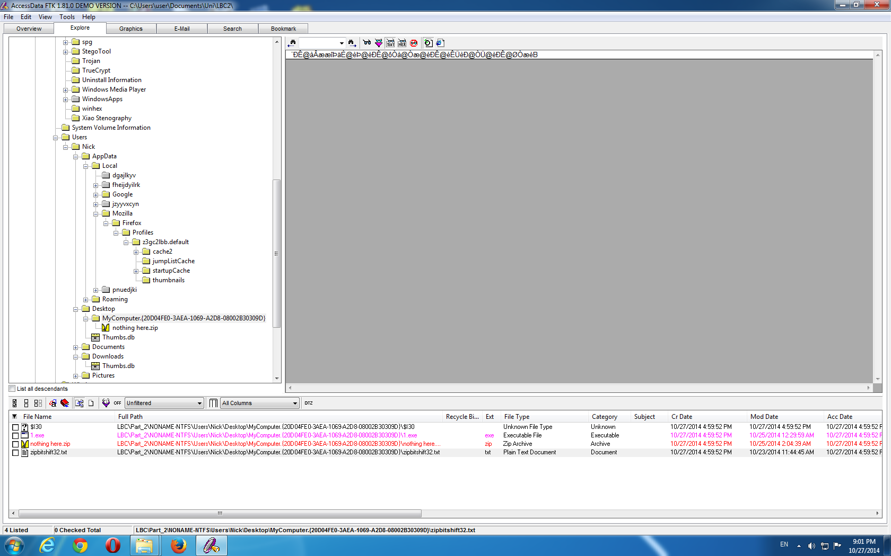

|  |  |
| --- | --- |
| **Item Number** | **Description** |
| 12 | A zip giving a further hint for item 4. |
| Location: | C:\Users\Nick\Desktop\MyComputer\nothing here.zip |

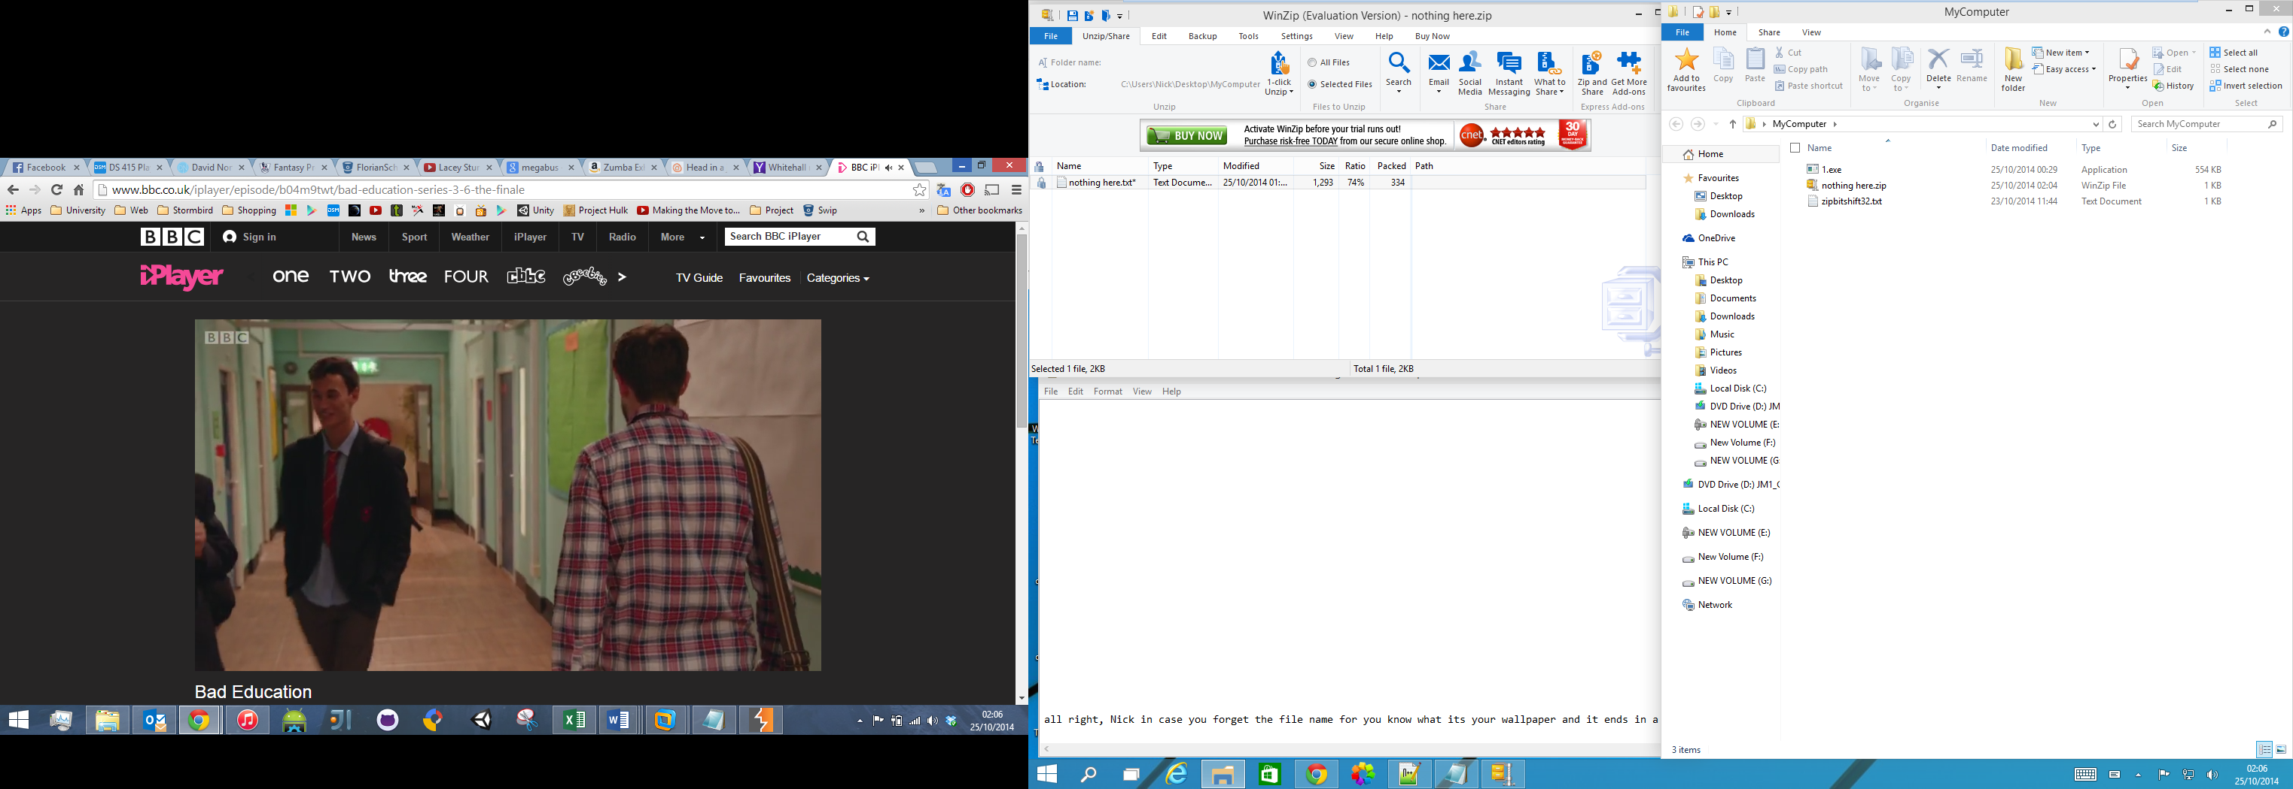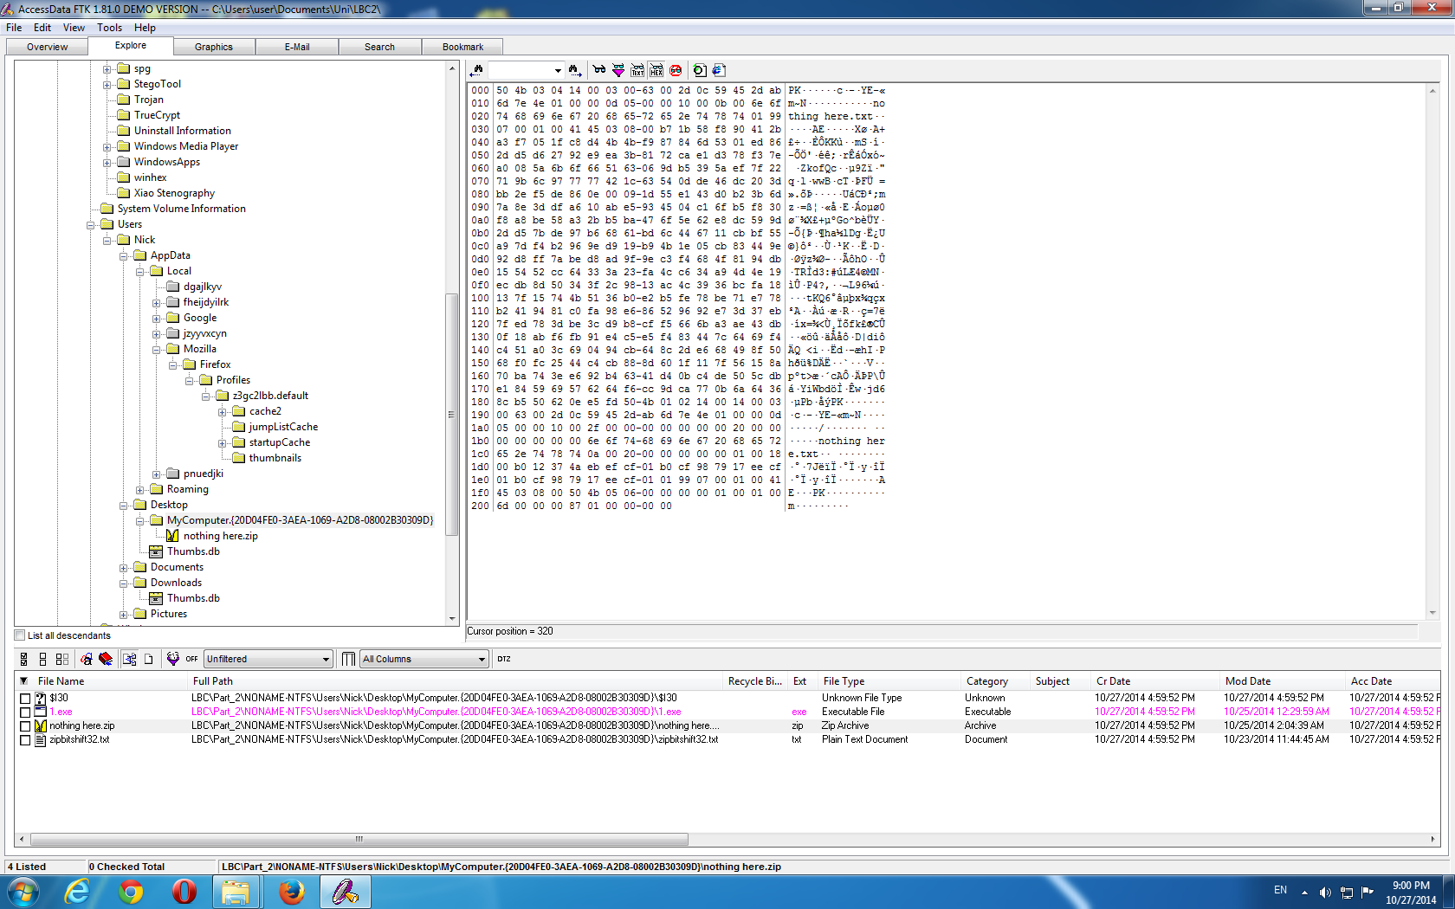

|  |  |  |  |  |  |  |
| --- | --- | --- | --- | --- | --- | --- |
| Item no. | Grade | Description of Evidence Item and its significance to the case. | Provenance Block | Method of Hiding | Password | Method to be used by examiner to find item |
|  |  |  |  |  |  |  |
| 1 | 1 | The file contains all sent emails.  The first email explains how Nick & Justin were mistaken as police due to their fancy dress outfits and that he wants to act as though he is a real officer.  In the second email Nick states that he’s purchased a police car and ha hidden an image of it using steganography.  In a third email Nick says that he has illegal images on a hidden or secure drive on his computer. He states that he has stored the password within a file name or photo. | **Name:** Sent-1  **Is Deleted:** No  **File Created:**  11 ‎October ‎2014, ‏‎18:28:41  **Last Written:**  16 ‎October ‎2014, ‏‎11:36:22  **Last Accessed:**  11 ‎October ‎2014, ‏‎18:28:41  **Logical Size:** 50.5 KB  **Physical Sector:** 1958,248  **Full path:**  C:\Users\Nick\AppData\Roaming\Thunderbird\Profiles\x4vt1wze.default\ImapMail\imap-mail.outlook.com\Sent-1 | Plain text | N/A | View the plain text email log found in the stated location. |
| 2 | 1 | Internet history with searching containing a vast amount of evidence useful information.   * Many search terms relating to impersonating a Police Officer * Looking to buy a police car * GSplit - File Splitter * Truecrypt & Bitlocker * Best ways to hide a password * Steganography tools and how to hide images in .bmp files. | **Name:** places.sqlite  **Is Deleted:** No  **File Created:**  27 ‎October ‎2014, 17:02:34  **Last Written:** ‎  24 ‎October ‎2014, ‏‎17:48:09  **Last Accessed:**  ‎27 ‎October ‎2014, ‏‎17:02:34  **Logical Size:** 10.0 MB  **Physical Sector:** 3,087,552  **Full path:**  C:\Users\Nick\AppData\Roaming\Mozilla\Firefox\Profiles\z3gc2lbb.default\places.sqlite | Plain text | N/A | View the plain text search history log found in the stated location. |
| 3 | 2 | This deleted file contains a list of many passwords. Many of them are either fake or not relevant to the case. However, there are 3 that are relevant.   1. Steg1 – First password for item 4. 2. Steg2 – Second password for item 4. 3. Stuf3 – Password for item 11. | Name**:** passwords.txt  **Is Deleted:** Yes  **File Created:** ‎  ‎23 ‎October ‎2014, 11:33:58  **Last Written:** ‎  23 ‎October ‎2014, ‏‎18:18:29  **Last Accessed:** ‎  ‎27 ‎October ‎2014, ‏‎17:04:40  **Logical Size:** 737 bytes  **Physical Sector:** 3,087,552  **Full path:**  C:\$Recycle.Bin\S-1-5-21-477737034-4021999012-1167862946-1000\passwords.txt | Plain text, deleted, some encoding | N/A | Extracted from recycle bin or seen in plain text using EnCase/FTK.  The second prefix is the encoding method. Using a tool such as Burp Suite these can be decoded. A few have been encoded using multiple methods, or the same method multiple times, but all are obvious when fully decoded.  PT – Plain text  B64 – Base64  AH – Ascii-Hex  OC – Octal  URL – URL  HTM – HTML |
| 4 | 5 | Hidden in the Windows wallpaper image, a hidden image of the illegal police car purchased is found. | Name**:** img17.bmp  **Is Deleted:** No  **File Created:** ‎  12 ‎October ‎2014, ‏‎00:15:41  **Last Written:** ‎  12 ‎October ‎2014, ‏‎00:15:41  **Last Accessed:**  12 ‎October ‎2014, ‏‎00:15:41  **Logical Size:** 5.93 MB  **Physical Sector:** 809,120  **Full path:** C:\Windows\Web\Wallpaper\High Resolution\img17.bmp | Steganography | letsbecops  wearecops | Having found item 1, 2 & 3 you know Steganography has been used somewhere on a bmp file and you have the two passwords.  Steganography detection software can be used to find the correct file, the large Windows 1o wallpaper .bmp files being the most suspicious.  In case this could have proved too difficult to find, there is a further hint in item 15 as to the file name.  Looking through the software installed ‘OpenPuff’ is listed as a Stegonography tool and accepts multiple passwords. Load in the image, enter both passwords and the evidence item ‘Purchased Car.png’ will be extracted. |
| 5 | 1 | Contains Bit Locker password in file name. | Name**:** tumblr_6y1qd_pa55wd_m6kxxbd_6y1_qiygpd.gif  **Is Deleted:** No  **File Created:** ‎ ‎ ‎  11 ‎October ‎2014, ‏‎15:56:31  **Last Written:** ‎ ‎  11 ‎October ‎2014, ‏‎15:56:32  **Last Accessed:** ‎ ‎  11 ‎October ‎2014, ‏‎15:56:32  **Logical Size:** 621 KB  **Physical Sector:** 791,411  **Full path:**  C:\Users\Nick\Pictures\Funny\ tumblr_6y1qd_pa55wd_645920-252879-640728-527032-384032-399773-249854-498135_qiygpd.gif | Plain text | N/A | As mentioned in item 1 a file name contains a password. The password is prefixed with ‘pa55wd’. The correct password is ‘m6kxxbd_6y1’, but I had to change this to the password recovery key as EnCase does not accept the actual password.  When you open the case in EnCase 7 it automatically prompts you to enter the recover key to unlock the drive. The key is:  645920-252879-640728-527032-384032-399773-249854-498135 |
| 6 | 4 | A folder that contains surveillance images taken using stolen police equipment. | Name**:** Suspects  **Is Deleted:** No  **File Created:** ‎ ‎ ‎  ‎11 ‎October ‎2014, ‏‎21:02:38  **Last Written:** ‎ ‎  11 ‎October ‎2014, ‏‎20:57:20  **Last Accessed:** ‎ ‎ 23 ‎October ‎2014  **Logical Size:** 7.32 MB  **Physical Sector:** N/A  **Full path:** E:\Suspects | Images stored in encrypted drive | 645920-252879-640728-527032-384032-399773-249854-498135 | After finding evidence item 5, use different combinations of the string ‘m6kxxbd_6y1_qiygpd’ until you find the correct password and unlock the drive. |
| 7 | 2 | An image, hidden as a zip file, containing both suspects as well as the purchased car. | Name**:** we rock.zip  **Is Deleted:** No  **File Created:** ‎ ‎ ‎  ‎11 ‎October ‎2014, ‏‎21:22:55  **Last Written:** ‎ ‎  28 ‎September ‎2014, ‏‎23:25:34  **Last Accessed:** ‎ ‎  ‎11 ‎October ‎2014, ‏‎21:40:01  **Logical Size:** 422 KB  **Physical Sector:** 1,907,872  **Full path:**  C:\Users\Nick\Pictures\we rock.zip | Changed file extension and header. | N/A | Change the file extension to .jpeg. The image will appear corrupt, so open it in notepad and change the header from ‘ZIP’ to ‘JFIF’. It will now open correctly. |
| 8 | 3 | A text file containing a list of the folders that contain a GSplit file in them. | Name**:** we rock.zip  **Is Deleted:** No  **File Created:** ‎ ‎ ‎  ‎17 ‎October ‎2014, ‏‎13:04:29  **Last Written:** ‎ ‎  22 ‎October ‎2014, ‏‎15:44:46  **Last Accessed:** ‎ ‎  ‎ 24 ‎October ‎2014  **Logical Size:** 107 B  **Physical Sector:** 62,826,502  **Full path:**  G:\NDcyMDZjNmY2M | Hidden in bad cluster | N/A | Using WinHex or EnCase/FTK view the G drive to see the file. |
| 9 | 4 | A text file that has a list of stolen police items. | Name**:** explorer.exe  **Is Deleted:** No  **File Created:** ‎ ‎  16 ‎October ‎2014, ‏‎19:14:58 ‎ ‎  **Last Written:** ‎ ‎  ‎25 ‎October ‎2014, ‏‎00:18:39  **Last Accessed:**  25 ‎October ‎2014, ‏‎00:21:56‎ ‎  **Logical Size:** 2.72 MB  **Physical Sector:** N/A  **Full path:**   * C:\Windows\bfsv.exe * C:\Users\Nick\Desktop\MyComputer\1.exe * C:\Users\Nick\Documents\disk2.gsd * E:\Suspects\Suspects 3.png * C:\Users\Nick\Downloads\testfour.gsd * C:\Program Files\FlexHEX\Structures\5tyle.fsd | Split into multiple files using GSplit. | N/A | Recover the listed files and place them in the same directory:   * C:\Windows\bfsv.exe * C:\Users\Nick\Desktop\MyComputer\1.exe * C:\Users\Nick\Documents\disk2.gsd * E:\Suspects\Suspects 3.png * C:\Users\Nick\Downloads\testfour.gsd * C:\Program Files\FlexHEX\Structures\5tyle.fsd   They can be quickly found using a keyword search for ‘GSplit’ in EnCase/FTK with item 8 for confirmation.  Once collected rename the items containing a number to ‘disk<number>.gsd’, for example:  1.exe 🡪 disk1.gsd  Finally run the exe file and it will recover the list. |
| 10 | 2 | A folder containing evidence items 11 & 12. | Name**:** MyComputer  **Is Deleted:** No  **File Created:** ‎ ‎  ‎27 ‎October ‎2014, ‏‎16:59:52 ‎ ‎  **Last Written:** ‎ ‎  ‎‎27 ‎October ‎2014, ‏‎16:59:52  **Last Accessed:**  ‎27 ‎October ‎2014, ‏‎16:59:52 **Logical Size:** 554 KB  **Physical Sector:** N/A  **Full path:**  C:\Users\Nick\Desktop\MyComputer | Folder CLSID changed. | N/A | The folder in its current state will open as if a link to My Computer. To change its CLSID simply run the hidden .bat script to change it back and access the folder. |
| 11 | 2 | Gives a hint to the password protecting the zip folder (item 12). | Name**:** zipbitshift32.txt  **Is Deleted:** No  **File Created:** ‎ ‎  ‎‎27 ‎October ‎2014, ‏‎16:59:52 ‎  **Last Written:** ‎ ‎  ‎‎‎23 ‎October ‎2014, ‏‎11:44:45  **Last Accessed:**  ‎‎27 ‎October ‎2014, ‏‎16:59:52 **Logical Size:** 49 bytes  **Physical Sector:** N/A  **Full path:**  C:\Users\Nick\Desktop\MyComputer\zipbitshift32.txt | Contents has been bit shifted left 32 bytes. | N/A | From the hint in the file name, it relates to the zip in the same folder and its contents have been bit shifted 32 bits.  Open the file in a hex editor such as Hex Workshop and use the Shift Right operation and select the 32 bit option.  This will reveal the plain text, which states “The password to the zip is tenth on the list”. This refers to the password file found earlier.  The tenth item is listed as stuf3 OC: rush4100. Decoding it using Octal using a tool such as Burp Suite gives the decoded password ‘rush2112’. |
| 12 | 4 | Gives a hint to which image has had Steganography run on it (item 4). | Name**:** nothing here.zip  **Is Deleted:** No  **File Created:** ‎ ‎  ‎‎27 ‎October ‎2014, ‏‎16:59:52  **Last Written:** ‎ ‎  ‎‎‎‎25 ‎October ‎2014, ‏‎02:04:39 **Last Accessed:**  ‎‎‎27 ‎October ‎2014, ‏‎16:59:52 **Logical Size:** 522 bytes  **Physical Sector:** N/A  **Full path:**  C:\Users\Nick\Desktop\MyComputer\nothing here.zip | Encrypted | rush2112 | The password can be found from item 11. Simply enter this in when extracting the contents. |